To my fantastic P5/6 class of 2019/20

As you left school on that March day that now seems so long ago,
When we would see you all again we didn’t quite know,
We had just finished our St Patrick’s day concert in the hall,
Reciting with such passion our class’ performance of ‘Ireland’s Call.’

With our class novel ‘Under the Hawthorn Tree’ still to complete,
Fractions, percentages and decimals - a big task to defeat.
Our ‘Ancient Egypt Mummification’ experiment hanging in the air,
Apostrophes and compass points to revise- I hoped you wouldn’t despair.

Home learning began and our government said ‘Stay inside,’
We knew we weren’t in for an easy ride,
You were missing your friends and (maybe) your teachers too,
Your parents worked hard to teach and care for you.

But a few weeks in and everything seemed not so bad,
You discovered interests you never knew you had,
More time to spend with family and do things you’ve always wanted to,
Gardening, painting rainbows, farming and exercising to name just a few.

As we stayed inside our homes, the world started to heal,
And suddenly lockdown didn’t seem like such an ordeal,
There’s clear water in Venice and blue skies over Delhi,
Wild animals are roaming free and big cities less smelly.

You worked so hard on Google Classroom every day,
Completing mental maths challenges and researching ‘The Rainforest’, all through May.
We missed the fun things we got up to in school, such as using Book Creator and iZak 9,
But just like our Random Acts of Kindness assembly, I knew I could ‘count on you’ and you’d be just fine.

I have such fond memories of this year spent with P5 and P6,
Our trips to the Planetarium and the Ardowen Theatre is where we got our kicks,
Back in class, learning Makaton and rapping the times tables until we knew them off by heart,
How immensely proud I am of all you boys and girls as we sadly depart.

We are looking forward to going back to school and for some normality to return,
But we will be grateful for this time and the lessons we have learned,
With so much more appreciation and love of life,
And together, we will have beaten this 2020 lockdown strife.

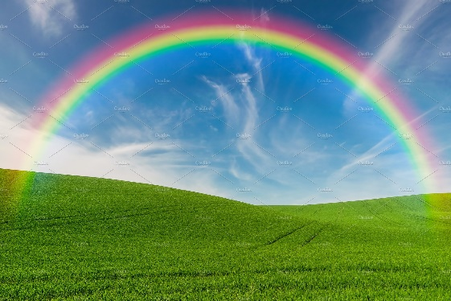

By Mrs McElroy
(June 2020)

